
P. O. Box 1618
Vancouver, WA 98668
www.murdock-trust.org
360.694-8415
“Partnering With Those Who Serve the Common Good”

Neal O. Thorpe Honorary Lecture

“Quantum Computing with Atoms and Photons”
By Dr. Boris Blinov

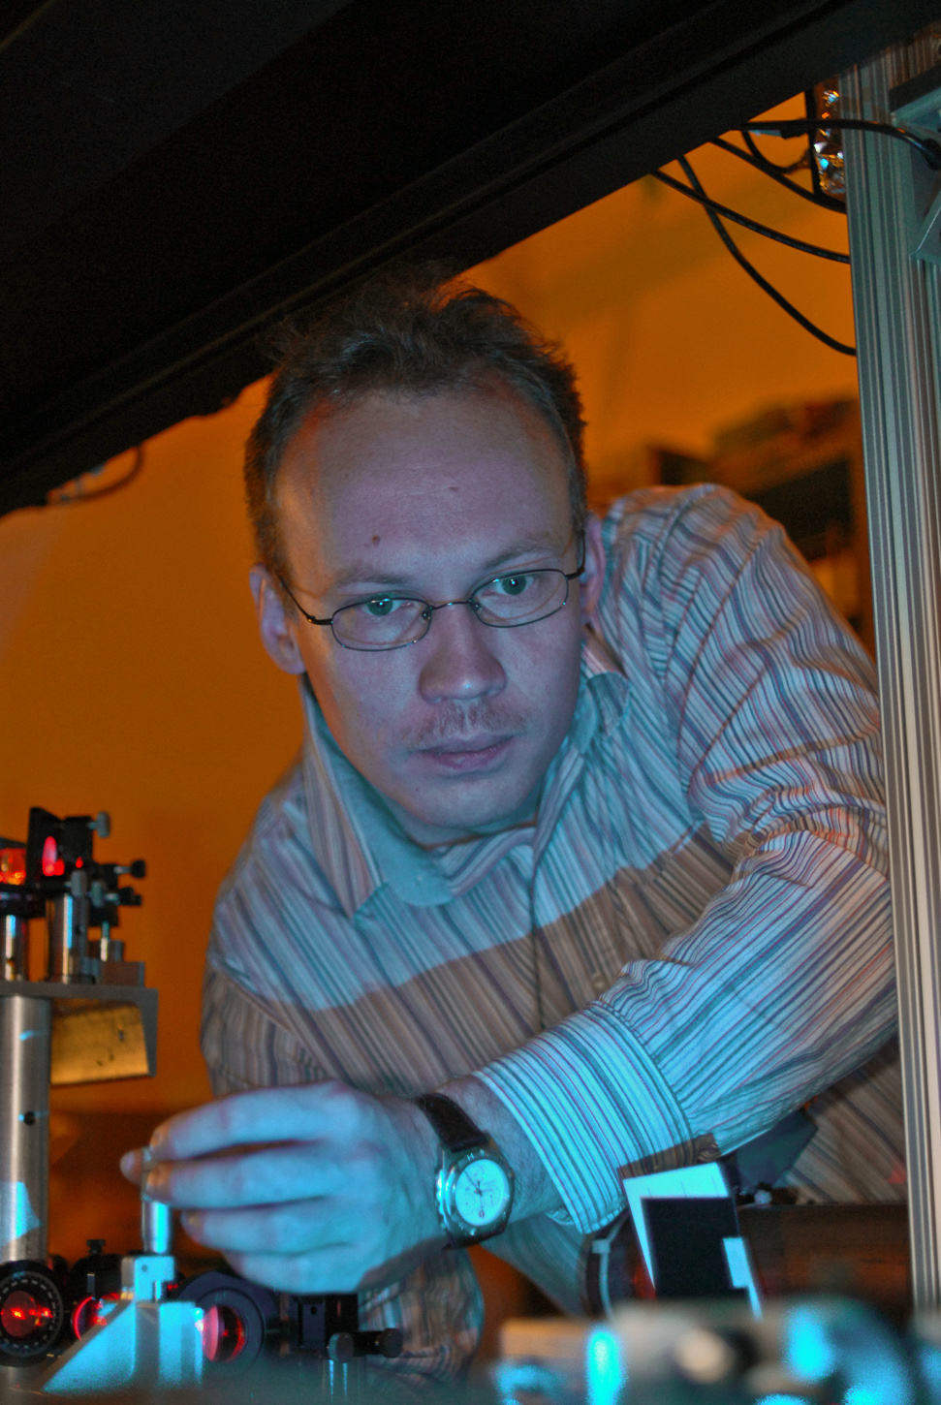
The Neal O. Thorpe Honorary Lecture at the Nineteenth Regional Conference on Undergraduate Research of the Murdock College Science Research Program, November 12-13, 2010, at Linfield College in McMinnville, Oregon, will be Dr. Boris Blinov, who will speak on Quantum Computing with Atoms and Photons. Dr. Blinov is Assistant Professor of Physics at the University of Washington. He graduated from Moscow State University in 1995 and received his Ph.D. from the University of Michigan in 2000, working on polarized beam storage and acceleration. As a post-doctoral fellow at the University of Michigan he explored trapped-ion quantum computing. Dr. Blinov will present his lecture at the conference banquet on November 12.
* * *

