SAMPLE ONLY: not prescriptive for your organization

Board Nominee Orientation Binder: Table of Contents

As featured in:
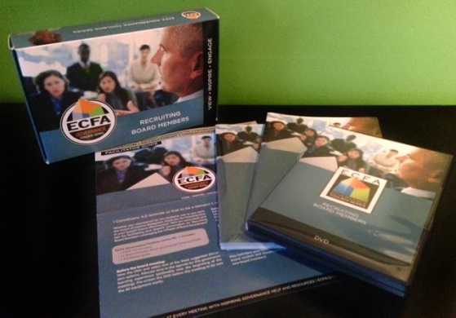 | ECFA Governance Toolbox Series No. 1 - Recruiting Board Members  Leveraging the 4 Phases of Board Recruitment: Cultivation, Recruitment, Orientation and Engagement  http://www.ecfa.org/ToolboxSeries.aspx

The Board Bucket Core Competency
“We believe that board members must sense God’s call to serve on the board of directors. We invest time in cultivating, recruiting, orienting and engaging
board members in their strategic role as stewards of our organization.
The first step in organizational sustainability is to inspire board members
to be highly committed and generous partners in ministry.”

Mastering the Management Buckets: 20 Critical Competencies for Leading Your Business or Nonprofit
The BOARD Bucket (Chapter 14 – pages 191-200)

Strategic Balls in the Board Bucket
1. RECRUIT for passion, not position.
2. PRAY before prospecting.
3. DATE before proposing.
4. INSPIRE your prospect to give generously.
5. PROPOSE marriage.
6. CONTINUE dating!
7. LEAVE a legacy.

Table of Contents:
- 31 Tabs
- A resource for the 4 social styles (see The People Bucket)
- ANALYTICALS (devour facts and information)
- DRIVERS (need the bullet points and executive summary)
- AMIABLES (need relationships and stories)
- EXPRESSIVES (need 4-color cover and Big Vision for the future)

Note: This template was originally presented by John Pearson for a CLA Tele-Seminar,
“6 Best Practices for More Effective Boards,” on March 27, 2009,
hosted by Christian Leadership Alliance.

© Copyright, 2009. John Pearson Associates, Inc. – All rights reserved.
www.ManagementBuckets.com
Permission granted to download this template for internal use only.

Board of Directors – Board Nominee Orientation Binder
Table of Contents (31 tabs) - 3G Global Ministries

 | INTRODUCTORY MATERIALS
1 | Introduction from the Chairman of the Board of Directors
2 | General Brochures, Publications, (eNewsletter, Website outline, etc.)
3 | Historical Snapshot, Honors, Awards, Notable News Clippings
 | BOARD OF DIRECTORS
4 | Current Board Members (Mini-Bios), Committees and Volunteer Structure
5 | Board Member Annual Affirmation Statement
 | - Future Board Meetings
 | - Letter of Invitation to Serve and Biographical Response Form
6 | Nomination and Election Procedures
7 | Bylaws, Articles of Incorporation, etc.
8 | Board Policies Manual
9 | Conflict of Interest Disclosure Letter
10 | Former Board Members & Board Chairs
11 | Board Meeting Agenda/Pages (of most recent meeting) – sample
12 | Board Issues for Next 3 Years; Skeletons!
 | FINANCE, BUDGET, IRS, ECFA REPORTS
13 | Annual Budget
14 | Current Financial Reports
15 | Audited Financial Statements
16 | ECFA Membership, Profile and Public Statistics
17 | IRS Form 990 (Return of Org. Exempt from Income Tax)
 | STRATEGIC PLAN & METRICS
18 | Strategic Thinking/Planning Process & Strategic Plan Placemat (11x17)
19 | Annual Satisfaction Surveys
20 | CEO SMART Goals & Board/CEO Accountability Process (Dashboard)
21 | Leading Indicators/Key Performance Indicators (KPIs), Statistics (charts and graphs)
22 | Peter Drucker's "Five Questions Every Nonprofit Organization Must Answer"
23 | "Radar Issues" (One-Pager) – “Our Assumptions About the Next 3 Years”
 | TEAM MEMBERS
24 | Organizational Chart & Mini-Position Descriptions: Staff Contact Info
25 | Team Member Mini-Bios; CEO Bio, CEO’s Top-5 "Strengths" (StrengthsFinder.com)
26 | Confidential Compensation Schedule
 | DEVELOPMENT
27 | Donor Development Program - Snapshot
28 | Direct Mail, Campaign/Project, Brochure Samples
29 | Development Program Annual and Three-year Goals
 | PROGRAMS AND SERVICES
30 | “Menu” of Programs and Services for “Primary Customers” and “Supporting Customers”
31 | Other
NOTES:

