Board Retreat Read-and-Reflect Worksheets
Great boards read at least one book a year to improve their governance competencies!

See the attached worksheets for board members to use when reading one book before your next board retreat:

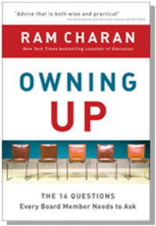 | 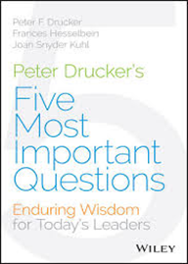 | 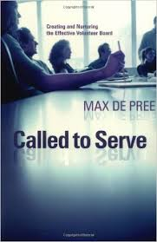

Option 1: OWNING UP: The 14 Questions Every Board Member Needs to Ask, by Ram Charan
Option 2: Peter Drucker’s Five Most Important Questions: Enduring Wisdom for Today’s Leaders, by Peter F. Drucker, Frances Hesselbein, and Joan Snyder Kuhl

Option 3: Called to Serve: Creating and Nurturing the Effective Volunteer Board, by Max De Pree

PLUS! Read a chapter from the forthcoming book, Lessons from the Boardroom, by Dan Busby and John Pearson, “Lesson 61: Great Boards Delegate Their Reading” (see pages 23-24).

“If you were marooned on a desert island and could have only a single book with you, what would you choose? Somebody once asked this question of G. K. Chesterton. Given his reputation as one of the most erudite and creative Christian writers in the first half of the twentieth Christian century, one would naturally expect his response to be the Bible. It was not. Chesterton chose Thomas' Guide to Practical Shipbuilding.”

The Life You’ve Always Wanted: Spiritual Disciplines for Ordinary People
John Ortberg

Option 1: A Board Retreat Tool: Ram Charan’s book, Owning Up

[sample retreat tool]
2016 Board Retreat
XYZ Ministry
Read & Reflect Worksheet

MEMO

DATE: March 6, 2016

TO: Board of Directors

FROM: Jane Doe

RE: Preparation for Board Retreat

We are prayerfully looking forward to meeting with all of you at the 2016 Board Retreat We want our time together to reflect the heart and spirit of Henry Blackaby’s memorable comment, “Find out what God is doing…and then join Him.”

This worksheet is designed to get everyone thinking in advance. We urge you to invest time in prayer and preparation BEFORE the board retreat. Please note this wisdom from Peter Drucker:
“The best way
to predict the future
is to create it.”
Peter Drucker

Reading Assignment
You have received the book, OWNING UP: The 14 Questions Every Board Member Needs to Ask, by Ram Charan. We’ll dig deep into this resource. And we’ll heed this reminder, also from Peter Drucker:
“Plans are only good intentions
unless they immediately degenerate into hard work.”

Drucker also said that “we now accept the fact that learning is a lifelong process of keeping abreast of change. And the most pressing task is to teach people how to learn.” So…what can we learn that will help us with board governance?

A “Read and Reflect Worksheet” is attached to this memo. After you’ve read the book, please jot down your thoughts and then bring the worksheet with you to the board retreat. Thanks! We’re looking forward to how God will lead you in this process.

Why Is This Important?

“Leaders must challenge the process
because systems will unconsciously conspire
to maintain the status quo and prevent change.”
The Leadership Challenge

Read and Reflect Worksheet
XYZ Ministry 2016 Board Retreat
Please bring the worksheet with you to the Board Retreat

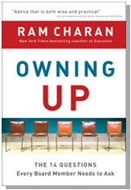

“The business landscape has changed. The game has changed. What boards do needs to change as well.”
Ram Charan

From the book’s website: www.ram-charan.com

Your world as a director has suddenly changed. You've seen members of other boards take the heat when their companies imploded. The managements of Lehman Brothers, Bear Stearns, Merrill Lynch, and Washington Mutual clearly failed, but so did their boards. Now the board of every company beset with problems is coming under scrutiny.

The pressure is on. Your board must own up to its accountability for the performance of the corporation. Governance now means leadership.

Boards must change their modus operandi to address the new and complex issues that are emerging. These include:
- Ensuring liquidity in the context of the global financial crisis
- Setting CEO performance targets in a very uncertain economy
- Assessing strategy and enterprise risk under extreme volatility

So what should boards do now? What should they be talking about in their meetings and executive sessions? What decisions must they make? How assertive must they be regarding company priorities and operating goals?

In Owning Up, business advisor and corporate governance expert Ram Charan answers these and other burning questions on the minds of directors and business leaders. He describes best practices that are emerging in boardrooms he has observed firsthand. And he provides practical recommendations on a range of issues, from compensation to dealing with external constituencies. Wisely attuned to the human side, he confronts the need for some boards to refresh their composition and for others to rebalance their board dynamics.

Directors, CEOs, general counsels, and operating executives will find here the guidance they need to meet the new and rising standards for corporate governance in this demanding business environment.

Reading  Options | OWNING UP: The 14 Questions Every Board Member Needs to Ask, by Ram Charan  2 Options:  Option 1. Read the entire book—and you may win a Starbucks card!  Option 2. Read these “6 Most Relevant Chapters” and scan the rest:  Chapter 1: Board Composition  Chapter 2: Risk Management  Chapter 4: CEO Succession  Chapter 5: Corporate Strategy  Chapter 12: Board Self-Assessment  Chapter 13: Micromanaging
Introductory  Critical  Questions: | Ram Charan makes some very strong statements at the beginning of the book. Do you agree with them?

Do you agree or disagree? | YES!  ABSOLUTELY! | TO SOME EXTENT | NOT  AT ALL
1. Has the business landscape changed?
2. Has “the game” changed?
3. Do boards need to change?
4. Does our board need to change?
5. Charan says that “Governance now means leadership.” Do you agree?

What changes, if any, should be made—and by when?

Question 1:  Board  Composition  A “Top-6 Chapter” | CHAPTER 1  Question 1: Is Our Board Composition Right for the Challenge?  Key Thought or Quotation:  Implication or Application for Our Board:

Question 2:  Risk  Management  A “Top-6 Chapter” | CHAPTER 2  Question 2. Are We Addressing the Risks That Could Send Our Company over the Cliff?  Key Thought or Quotation:  Implication or Application for Our Board:

Question 3:  Crisis  Management | CHAPTER 3  Question 3. Are We Prepared to Do Our Job Well When a Crisis Erupts?  Key Thought or Quotation:  Implication or Application for Our Board:

Question 4:  Succession  Planning  A “Top-6 Chapter” | CHAPTER 4  Question 4. Are We Well Prepared to Name Our Next CEO?  Key Thought or Quotation:  Implication or Application for Our Board:

Question 5:  Corporate  Strategy  A “Top-6 Chapter” | CHAPTER 5  Question 5. Does Our Board Really Own the Company's Strategy?  Key Thought or Quotation:  Implication or Application for Our Board:

Question 6:  Information  Management | CHAPTER 6  Question 6. How Can We Get the Information We Need to Govern Well?  Key Thought or Quotation:  Implication or Application for Our Board:

Question 7:  Executive  Compensation | CHAPTER 7  Question 7. How Can Our Board Get CEO Compensation Right?  Key Thought or Quotation:  Implication or Application for Our Board:

Question 8:  “The Lead Director” | CHAPTER 8  Question 8. Why Do We Need a Lead Director Anyway?  Key Thought or Quotation:  Implication or Application for Our Board:

Question 9:  Governance  Committee | CHAPTER 9  Question 9. Is Our Governance Committee Best of Breed?  Key Thought or Quotation:  Implication or Application for Our Board:

Question 10:  Maximizing a Board Member’s Time | CHAPTER 10  Question 10. How Do We Get the Most Value out of Our Limited Time?  Key Thought or Quotation:  Implication or Application for Our Board:

Question 11:  Executive Sessions | CHAPTER 11  Question 11. How Can Executive Sessions Help the Board Own Up?  Key Thought or Quotation:  Implication or Application for Our Board:

Question 12:  Board Self-Assessment Process  A “Top-6 Chapter” | CHAPTER 12  Question 12. How Can Our Board Self-Evaluation Improve Our Functioning and Our Output?  Key Thought or Quotation:  Implication or Application for Our Board:

Question 13:  Micromanaging Symptoms  A “Top-6 Chapter” | CHAPTER 13  Question 13. How Do We Stop from Micromanaging?  Key Thought or Quotation:  Implication or Application for Our Board:

Question 14:  Activist Donors or Others  Is this chapter relevant to our situation? | CHAPTER 14  Question 14. How Prepared Are We to Work with Activist Shareholders and Their Proxies?  Key Thought or Quotation:  Implication or Application for Our Board:

REMINDER!
Please bring this worksheet and the book with you to the retreat.

Option 2: Board Retreat Read-and-Reflect Worksheet
Great boards read at least one book a year to improve their governance competencies!

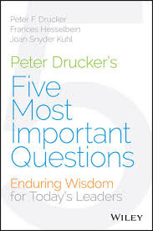 | Peter Drucker’s Five Most Important Questions: Enduring Wisdom for Today’s Leaders  by Peter F. Drucker, Frances Hesselbein, and Joan Snyder Kuhl

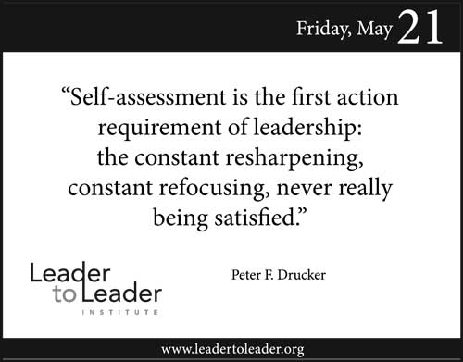 | 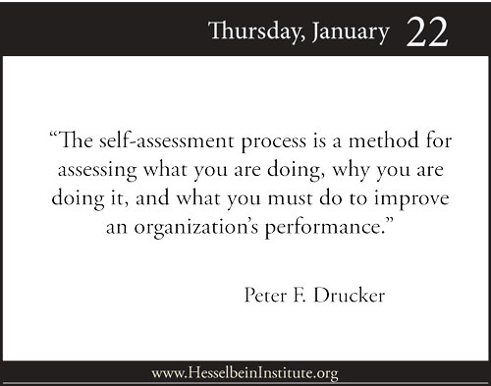

A Board Retreat Tool:
Peter Drucker’s Five Most Important Questions:
Enduring Wisdom for Today’s Leaders

[sample retreat tool—customize for your board’s unique needs]
2016 Board Retreat
XYZ Ministry
Read-and-Reflect Worksheet

MEMO

DATE: June 14, 2016

TO: Board of Directors

FROM: Jane Doe, Board Chair

RE: Preparation for Board Retreat

We are prayerfully looking forward to meeting with all of you at the 2016 Board Retreat. We want our time together to reflect the heart and spirit of Henry Blackaby’s memorable comment, “Find out what God is doing…and then join Him.”

This worksheet is designed to get everyone thinking in advance. We urge you to invest time in prayer and preparation BEFORE the board retreat. Please note this wisdom from Peter Drucker:
“The best way
to predict the future
is to create it.”
Peter Drucker

Reading Assignment
You have received the book, Peter Drucker’s Five Most Important Questions: Enduring Wisdom for Today’s Leaders, by Peter F. Drucker, Frances Hesselbein, and Joan Snyder Kuhl. We’ll dig deep into this resource. And we’ll heed this reminder, also from Peter Drucker:
“Plans are only good intentions
unless they immediately degenerate into hard work.”

Drucker also said that “we now accept the fact that learning is a lifelong process of keeping abreast of change. And the most pressing task is to teach people how to learn.” So…what can we learn that will help us with board governance?

A “Read-and-Reflect Worksheet” is attached to this memo. After you’ve read the book, please jot down your thoughts and then bring the worksheet with you to the board retreat. Thanks! We will look forward to hearing how God will lead you in this process.

Why Is This Important?
“Leaders must challenge the process
because systems will unconsciously conspire
to maintain the status quo and prevent change.”
The Leadership Challenge, by James M. Kouzes and Barry Z. Posner

Read-and-Reflect Worksheet
XYZ Ministry 2016 Board Retreat
Please bring the book and the worksheet with you to the Board Retreat.

Peter Drucker’s Five Most Important Questions:
Enduring Wisdom for Today’s Leaders
by Peter F. Drucker, Frances Hesselbein, and Joan Snyder Kuhl

Read this brief review:
http://urgentink.typepad.com/my_weblog/2015/10/peter-druckers-five-most-important-questions.html

Reading  Options | 2 Options:  Option 1. Read the entire book (and the commentary on each question)—and you may win a Starbucks card! You’ll especially enjoy the interesting color commentary by millennials in each chapter.  Option 2. Read just Peter Drucker’s comments on the five questions (less than 35 pages).  Why Self-Assessment? (pages 1-6)  Question 1: What Is Our Mission? (pages 7-11)  Question 2: Who Is Our Customer? (pages 19-23)  Question 3: What Does the Customer Value? (pages 35-38)  Question 4: What Are Our Results? (pages 47-52)  Question 5: What Is Our Plan? (pages 61-68)
Introductory  Critical  Question | Peter Drucker makes a very strong statement at the beginning of the book. Do you agree with him?  “Although I don't know a single for-profit business that is as well managed as a few of the nonprofits, the great majority of the nonprofits can be graded a ‘C’ at best. Not for lack of effort; most of them work very hard. But for lack of focus, and for lack of tool competence. I predict that this will change, however, and we at the Drucker Foundation [now the Frances Hesselbein Leadership Institute] hope to make our greatest impact in these areas of focus and tool competence.” (page 2)

Question 1:  What is our mission? | Our organization’s mission is to…

Is it time to re-visit our mission statement? Measure our mission statement against this “Top-10 List.”

Top-10 Ingredients That Create an  Eloquent & Arresting Mission Statement  Our mission… | YES!  ABSOLUTELY! | TO SOME EXTENT | NOT  AT ALL
1. Is short and easily focused.
2. Is clear and easily understood.
3. Defines why we do what we do, why the organization exists.
4. Does not prescribe means.
5. Is sufficiently broad.
6. Provides direction for doing the right things.
7. Addresses our opportunities.
8. Matches our competence.
9. Inspires our commitment.
10. Says what, in the end, we want to be remembered for.
Note: These 10 questions are from The Five Most Important Questions Self-Assessment Tool: Participant Workbook, by Peter F. Drucker and Frances Hesselbein Leadership Institute (available on Amazon).

Bonus Question:
Does our mission statement...fit on a t-shirt?

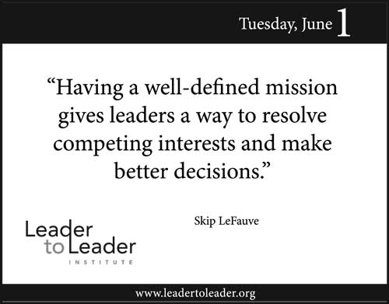 | 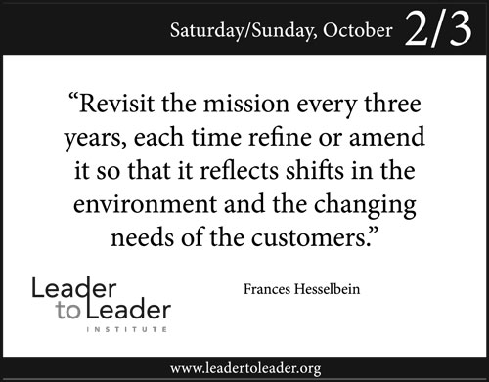

Question 2:  Who is our customer? | Peter Drucker distinguishes between “primary” and “supporting” customer and says that your primary customer is “the person whose life is changed through your work.”  In your opinion, who is our primary customer?

Question 3:  What does our customer value? | Research is a key part of discerning what our customers value. What would you like to know about our primary customer that we don’t know today?

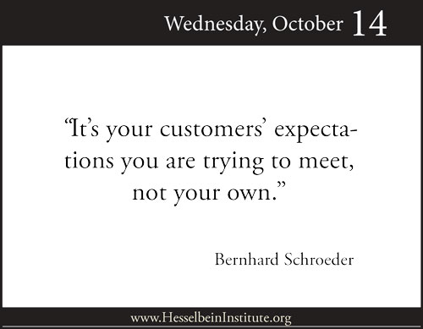
Question 4:  What are our results? | In all of his writings, Drucker talks about planned abandonment—“sloughing off yesterday.” What are some of the sacred cows or dead horses we should abandon in order to make room for our most critical priorities and the achieving of God-honoring results?

Question 4:  What are our results?  Optional  Homework | John Pearson, author of Mastering the Management Buckets: 20 Critical Competencies for Leading Your Business or Nonprofit, begins his book (the first “bucket” or core competency) with “The Results Bucket.”  Optional:  Visit: http://managementbuckets.com/results-bucket to download and read “The Results Bucket” chapter from John’s book.  Then…please jot down any insights that would apply to our present and future situation.  Insights:

Question 5:  What is our plan? | Peter Drucker says that an effective plan involves five elements:  - Abandonment  - Concentration  - Innovation  - Risk taking  - Analysis  In your opinion, which one of the five elements (above) are we most competent in? Why?  Which one element (above) needs more of our focus? Why?

Thanks for praying and preparing for our important time together!

“Is there anyone here who, planning to build a new house, doesn’t first sit down and figure the cost so you’ll know if you can complete it? If you only get the foundation laid and then run out of money, you’re going to look pretty foolish. Everyone passing by will poke fun at you: ‘He started something he couldn’t finish.’”
Luke 14:28-30 The Message

More Drucker Resources | Visit: The Drucker Bucket: http://managementbuckets.com/drucker-bucket  Read: Drucker & Me: What a Texas Entrepreneur Learned from the Father of Modern Management, by Bob Buford - http://urgentink.typepad.com/my_weblog/2014/04/drucker-and-me.html  Read: The Practical Drucker: Applying the Wisdom of the World’s Greatest Management Thinker, by William A. Cohen - http://urgentink.typepad.com/my_weblog/2014/01/the-practical-drucker.html

Please bring the book and the worksheet with you to the Board Retreat.

Option 3: Board Retreat Read-and-Reflect Worksheet
Great boards read at least one book a year to improve their governance competencies!

Called to Serve:
Creating and Nurturing the Effective Volunteer Board
by Max De Pree
Contrarian wisdom!
Just 91 pages!

Do it yourself version!
Step 1: Inspire a board member to create a customized “Read-and-Reflect Worksheet” that aligns with the current and specific needs of your board.

Step 2: Review the worksheet formats in Option 1 and Option 2—and create your own for Called to Serve.

Step 3: Review John Pearson’s book review and/or blog posts on Called to Serve and select various questions and emphases that address your board’s unique situation.

Blog Posts: Called to Serve
As Feb. 1, 2017, the following blog posts have been written (with five to 10 more to come in early 2017):
Date | Visit: www.ecfagovernance.blogspot.com
Dec. 31, 2016 | What Will You Measure in 2017?
Jan. 17, 2017 | Called to Serve: Violence and Committee Meetings
Jan. 27, 2017 | Called to Serve: Loyalty Is Never Sufficient
Jan. 31, 2017 | Called to Serve: Challenged With Measurable Work

John Pearson’s book review (see next page):
Dec. 7, 2016 | Called to Serve: Creating and Nurturing the Effective Volunteer Board
http://urgentink.typepad.com/my_weblog/2016/12/called-to-serve-creating-and-nurturing-the-effective-volunteer-board.html

Called to Serve:
Creating and Nurturing the Effective Volunteer Board
by Max De Pree

Your Weekly Staff Meeting eNews, edited and published by John Pearson, December 7, 2016 (used by permission)

http://urgentink.typepad.com/my_weblog/2016/12/called-to-serve-creating-and-nurturing-the-effective-volunteer-board.html

BOOK REVIEW

Issue No. 352 of Your Weekly Staff Meeting features two thin books on board governance—the perfect size to inspire your board and educate your staff. And for the record—this is NOT fake news! Plus, this reminder: check out my 20 management buckets (core competencies) at http://managementbuckets.com/20managementbuckets.

A Contrarian's Wisdom: Called to Serve

I tilt towards books that lean towards the contrarian quadrant. Example: former USC President Steven Sample's book, The Contrarian’s Guide to Leadership. Before buying a book, he prefers a five-minute conversation with someone who has already read it.

So when I had a five-minute conversation with consultant and author Dave Coleman about Max De Pree’s 91-page contrarian gem, it fed my board governance book-addicted soul. I love this book and the title: Called to Serve: Creating and Nurturing the Effective Volunteer Board.

Contrarian Max De Pree writes:

• “There is a reason why this is a small book. We want it to be useful, but not a burden.”
• “We believe good people need reminders and an occasional nudge, not a sermon.”
• “A good board will measure the appropriate inputs as well as the outputs. Failure to measure what matters damages our future.”
• “My friend Jim Beré…once told me that he would serve only on boards that had hard-working executive committees.”

Commenting on board committees, De Pree notes the story of the English visitor who watched his first American football game and observed,
“The game combines the two worst elements of American culture—
violence and committee meetings.”

Rather than penning a 300-page snoozer, De Pree crafts a coaching conversation (a series of letters) with a young leader and his first CEO/board relationship. It’s easy reading and the short epistles are extraordinary.

Board service, writes De Pree, should be “demanding in the best sense of the word.” He lists three other characteristics of great boards:
• Lively
• Effective
• Fun to serve on

CEOs will appreciate every page: “…the chief responsibility of boards is to be effective on behalf of the organization.” He adds, “Effective boards, in a nutshell:
• remember the long view,
• remember that the president and staff are human,
• and do the work of the board…”
• Plus this:
“Most of the work of the board takes place
through the implementation of an agenda.”

More contrarian pokes-in-the-ribs:

• “Many high-priced consultants will tell you to have the shortest possible mission statement. I don’t happen to think that is such a great idea.”
• “I feel that the closer an organization comes to being defined as a movement, the closer it will come to fulfilling its potential.”
• “I’m a great believer that management should be invited into the board’s world but that the board should not go into management’s area.”
• “The chairperson should not permit anyone to read to the board.”

Max De Pree served as board chair of Fuller Seminary—and get this—the seminary honored him with the establishment of the Max De Pree Center for Leadership in 1996. His day job was with Herman Miller, the office furniture company, where he served as president from 1980 to 1987 (and as a board member until 1995). His book, Leadership Is an Art, has sold more than 800,000 copies. (See also Leading Without Power: Finding Hope in Serving Community.)

Effective boards do very good planning, says De Pree. He lists three planning questions and then suggests who must be involved in the planning. “…some people need to be involved, to be blunt, because they are going to pay the bill.”

He balances the CFO’s involvement in planning with this: “Planning by the board ought always to include the chief financial officer, a bringer of necessary reality to the process. Of course, the chief financial officer should never have a role that stymies the vision. Some realities have priority over numbers.”

Oh, my—I could fill a year’s worth of eNewsletters with his contrarian coaching!

• “Loyalty by itself is never sufficient. You always have to link loyalty and competence.”
• “When an organization demands true leadership and the results justify the time and energy, good boards respond with gusto.”
• “Another crime, it seems to me, is to give really good people poor leadership.”

Trust me—this book will not disappoint. All 91 pages are packed with power. Perfect snippets for your “10 Minutes for Governance” segment at every board meeting. (You do that, right?) I’ll close with a story.

Addressing the importance of creating time in the agenda for board reflection, he writes, “I remember the story, perhaps apocryphal, about President Eisenhower and his secretary of state, John Foster Dulles. Dulles was an inveterate traveler. He seemed to be on the go continuously. At one point during the discussion of a serious problem, President Eisenhower said to him,
‘Don’t just do something,
stand there.’

Sometimes it’s easier to be busy than to take the time to be reflective.”

Your Weekly Staff Meeting Questions:
1) Max De Pree writes, “…a board can be only as good as management will help it become.” So how effective is your organization’s CEO and senior team in helping the board be effective—without inappropriately doing the board’s work?
2) De Pree recommends that “Key proposals and issues like building programs or fund drives should always come to the board through its committees at least twice.” Think back for three years—has this been your practice?

To order from Amazon, click on the link for:
Called to Serve: Creating and Nurturing the Effective Volunteer Board, by Max De Pree
http://urgentink.typepad.com/my_weblog/2016/12/called-to-serve-creating-and-nurturing-the-effective-volunteer-board.html

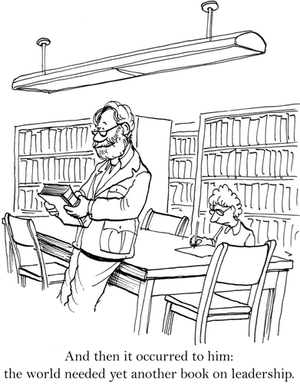
Excerpt from the forth-coming book:
Lessons from the Boardroom, by Dan Busby and John Pearson
Section 2: Boardroom Tools, Templates and Typos
ECFAPress (July 2017) – © Copyright, 2017. ECFA. All rights reserved. Used by permission.

LESSONS FROM THE BOARDROOM  Dan Busby & John Pearson | Lesson 61: Great Boards Delegate Their Reading  Deputize a “Readers Are Leaders” Champion

“If you were marooned on a desert island and could have only a single book with you, what would you choose? Somebody once asked this question of G. K. Chesterton. Given his reputation as one of the most erudite and creative Christian writers in the first half of the twentieth Christian century, one would naturally expect his response to be the Bible. It was not. Chesterton chose Thomas' Guide to Practical Shipbuilding.”

The Life You’ve Always Wanted: Spiritual Disciplines for Ordinary People
John Ortberg

I was shocked—but pleasantly shocked.

At a coffee break in a two-day board enrichment workshop, a life-long learning CEO asked me to recommend “the best governance book” his board should read. So we strolled over to the resource table and I began my lecture.

Me: “Actually, there is no ‘one’ perfect book for every board. It depends on many factors: previous board experience (the good kind!), your board’s operating philosophy (the continuum from Policy Governance® to hands-on boards), your board’s competencies in 10 or more traditional roles and responsibilities…”

He interrupted. (Apparently, I was preaching, not helping.)

CEO: “Yeah, yeah. I get all that. But what would you recommend?”

Me: “OK. But are you looking for a faith-based governance book—or wanting to address any specific issue or opportunity? For example, here’s a really good one: Owning Up: The 14 Questions Every Board Member Needs to Ask, by Ram Charan. I especially appreciate how boards must wrestle with the question, ‘Does the board own the strategy?’”

CEO: “We’ve already read that. Great book!”
Me: “Way to go! Then how about this one: The Imperfect Board Member: Discovering the Seven Disciplines of Governance Excellence, by Jim Brown. It’s not faith-based, but the author is—and get this—the board expert in this Patrick Lencioni-type business fable is a pastor!”

CEO: “We read it!”

Me: “What is this—a quiz show? Wow! Your board is well-read. How about this one: Best Practices for Effective Boards, by Fairbanks, Gunter, and Cauchenour?”

Finally—I pitched a book that his board had not read. I also mentioned several more (see the appendix), including the Harvard Business Review article, “What Makes Great Boards Great,” by Jeffrey Sonnenfeld. The author notes, “It’s not rules and regulations. It’s the way people work together” that creates a great board.

We’ve observed that there are several best practices that learning boards embrace:

Learning boards feature brief book reviews at every board meeting. Great boards delegate their reading. Every board member doesn’t need to read every governance book. However, with advance planning and motivation, the board chair can inspire individual board members to read and report on a helpful governance book. Some boards set the iPhone timer on the book reviewer for four or five minutes. If the reviewer concludes the report before the bell rings, he or she earns a Starbucks card!

Learning boards inspire everyone to read the same book prior to the annual board retreat. Select one stimulating book for everyone to read and include a “Read-and-Reflect Worksheet.” Provide three options (Good—read five chapters; Better—read eight chapters; Best—read every chapter). Invite selected board members to share four-minute reviews of their assigned chapters. You’ll be amazed at the preparation! (No one wants to be remembered as the unprepared presenter.)

Learning boards deputize a “Leaders Are Readers” champion. Appoint one board member to keep the “leaders are readers” core value on the front burner. Provide a small budget so he or she can keep abreast of the latest trends, resources, training, books, blogs, videos, toolboxes, and websites that will help your board be life-long learners.

So…what is “the best governance book” your board should read next? It depends, of course, on your unique situation. As you spiritually discern God’s direction for your ministry, your journey can be enhanced by the books you read (or listen to). Inspire your board to read!

BOARDROOM  LESSON | Great boards delegate their reading. Appoint an avid reader on your board as your “Leaders Are Readers” champion. Provide a small budget and inspire your champion to keep life-long governance learning top of mind for all board members. Your CEO, your staff, your volunteers, and your donors will be blessed to know that your board continues to learn and enhance their governance competencies.

BOARD ACTION STEPS:
- 1. Appoint: Inspire a board member (perhaps a member of your governance committee) to be your “Leaders Are Readers” champion with a brief focus on governance at each board meeting.
- 2. Review: Keep a running list of books and resources that the board has read in recent years—and inspire new board members to become familiar with the key concepts.
- 3. Read! Don’t just talk about reading—do it! Create the expectation in your board member recruitment process that all board members will continue to sharpen their skills, for example, in governance, spiritual discernment, and trend-spotting.

PRAYER: “Lord, many of us have experienced profound personal insights by reading the right book at the right time. Some of us have even made life-altering decisions after reading significant books. So guide us in our selection of the books that our board should read and review. Amen.”

