**Mental Health/Pastoral Care Strategy**

**Overview**

With the need for a practical strategy for Mental Health that is transferable for churches to use, we are looking to put our existing Pastoral Care Ministries into a reproducible format that will take our Mental Health Initiative to the next level. This will allow us to have an integrated strategy for Mental Health and Care across the church and fulfill our mission of reducing stigma and caring for the Mental Health needs of our members and those in the community.

**Current Mental Health Care Continuum**

Below is a list of our Mental Health Care Ministries in a continuum from small to big investments in people’s lives. We start with Crisis Care which is anchored by our Minister of the Day (MOD) where our staff steps in to listen, love on, pray for, and point people to their next steps in the midst of whatever crisis they find themselves in. We then offer Comfort Care for those who are experiencing a need for comfort during some kind of loss, hospitalization, or other need. These are typically specific events or services through which we meet them in their pain. Next are Connection type ministries which provide support through groups for a wide range of Mental Health needs. Finally, we offer Counsel for individuals and couples related to life’s challenges and issues and work with those struggling with persistent mental health needs and their families to help them get the best care possible.

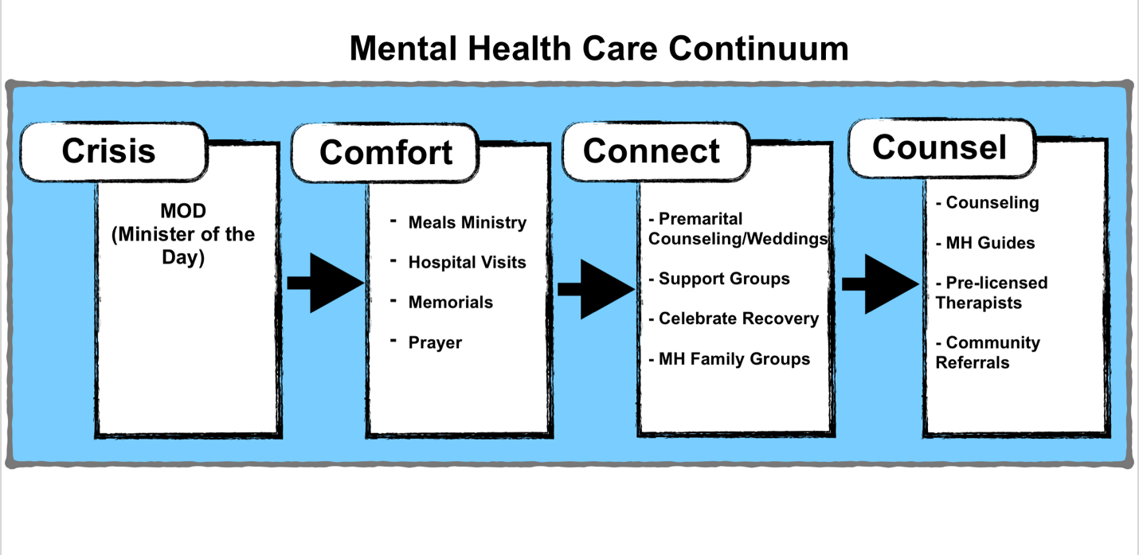

**Mental Health Care Strategy**

The strategy we are building to create and refine a replicable, transferable process of caring for our church members and community follows the strategy of our church by moving individuals through a funnel in which they will have access to a variety of resources and be presented with different ministries from which they can receive care. We start with our Mental Health Community which provides a great front door and safe place for individuals who are living with Mental Illness and the one’s who support them. In addition to the monthy community we will have other community oriented events around Mental Health. We are able to raise awareness, educate and connect people to resources both within and outside the church. We then want to take willing and compassionate individuals who want to learn more or serve in this ministry to a place of deeper understanding of the core values, mission, vision, and practical application of our Mental Health Initiative and all the aspects of Mental Health Care at Saddleback Church. This includes 4 core classes that outline why mental health is important, how we move people towards the health and care they need, what we offer at the church, and what community resources are available and how to navigate those systems. We will also include other trainings and seminars to further equip and educate on various aspects of mental health (i.e. Navigating a Mental Health Crisis, etc.).

Next is our support group system for getting people into community as they work through the concerns and challenges unique to their mental health issue or the issue of a loved one. We offer both our support group and Celebrate Recovery ministries for those living with a mental health concern as well as education and regular small groups for family members and loved ones supporting someone who is living with a mental health concern.

Finally we are able to provide care and support for the individual based on our Mental Health Care Continuum where we can customize referrals, resources, and care based on that person’s specific and unique needs to provide hope, encouragement, and next steps towards wellness to help them receive the best care possible.

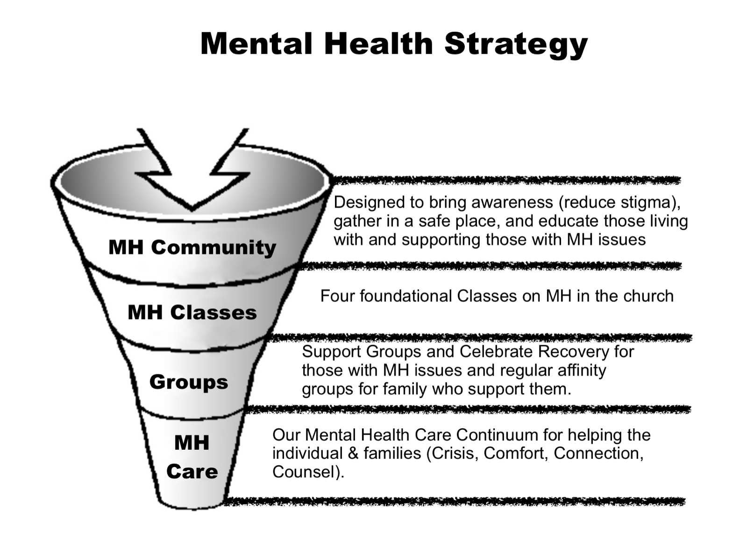

Mental Health Trainings

**Ministry Development**

To build out this strategy, we are working on the following initiatives in this first phase with more areas to develop as we reach these goals:

**Rewrite and Format of the Church Counselor Training**

We are currently rewriting and filming the Church Counselor Training to align with our strategy and provide online training and support for our regionals and those outside the church who would want to receive training. This helps us ensure everyone gets the same content and it can be implemented by any of our campuses.

**Development of Mental Health Classes**

We are in the process of outlining what material and information we would like in these classes and how to best design and deliver them. They will follow a similar format to our Church Counselor Training with online as well as live options.

**Support Group Assessment**

We are reviewing the support group training as well as the types of groups we currently offer and will be assessing the needs we have and the changes we need in order to make sure we have all our mental health and other concerns covered.

**Mental Health Guides**

We are developing volunteers who will be trained to come along side of individuals living with persistent mental illness to guide them through the process of connecting to the resources they need. They will also help families explore how to best support and help their loved ones as the family members are often the primary means of support.

**MOD Online Tool**

We are working on an online tool for our Pastors and staff to quickly access all of our resources online related to MOD. This will include training, how to handle situations, emergency information and resources.

**Saddleback Cares**

When we resume on campus we will have a Mental Health/Care area called Saddleback Cares combined with CR to help those who are in need develop a customized plan for their next steps and ministries/resources we have for them. We will also develop an online tool for doing the same thing so those in need can quickly get to our resources.

**PD Church Development**

We will be working to make sure each of these areas is reproducible for those in our PD network so we can support them in this initiative and further the initiative globally.